Head Office
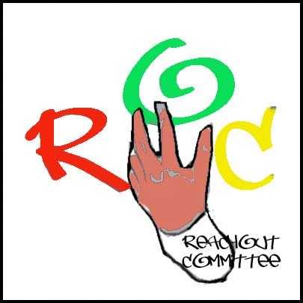Camilla Place
130 Dundas St. East, Suite 200
Mississauga Ontario L5A 3V8
Office tel. (289) 232-6407* (416) 571-9337 (24hr)
Reachout-committee@sympatico.ca
www.reachout.jimdo.com

13 October 2010

Dear Potential Panelist

We are writing to invite you to participate in a Youth Forum that will be held in the Region of Peel. The Forum will take place from 11 – 4PM several locations in Peel listed below. The Youth Forum is funded by the Ontario Trillium Foundation, to address youth violence, abuse, and risky behaviour and promote youth development and leadership amongst Black youth. The purpose of the Youth Forum is to give Black youth a voice in their communities and to provide information to adults making decisions that affect their lives. We believe that truly effective youth programs are marked by high levels of youth involvement, not just as program recipients, but as valuable resources who give program direction. When youth have a voice, a voice that's heard and acted on by adults, they have power to change their world for the better.

We invite you to serve on a Listeners Panel for the Forum. Your role would be to listen to the presentations by youth and then provide a brief (5 minute) acknowledgement and reaction to what has been said. A committee of youth and adults identified you as someone who is in a position of influence that could potentially use the information to promote a better understanding of the needs and realities of young people in the Region of Peel.

The dates for the Youth Forums and Workshops are
- 9 October 2010 – St Francis Xavier Secondary Mississauga - 11-4 pm
- 16 October 2010 - St Gertrude Elementary Mississauga - 11-4pm
- 30 October 2010 - St Gertrude Elementary Mississauga - 11-4pm
- 13 November 2010 – St Gertrude Elementary Mississauga - 11-4pm
- 27 November 2010 - St Francis Xavier Secondary Mississauga - 11-4 pm
- 11 December 2010 – Notre Dame Secondary Brampton – 11-4 pm
MORE DATES TO FOLLOW
We will follow up this letter with a phone call to see whether or not you are able to participate. Should you wish to contact us sooner, please call 289-232-6407 or 416-571-9337

Thank you.

WAVE for CHANGE Committee

