WAVE FOR CHANGE

WORKING

AGAINST VIOLENCE EVERYWHERE

FOR CHANGE

FORUMS AND WORKSHOPS

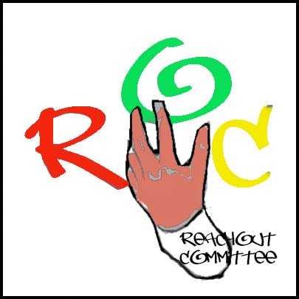

**Head Office**

**Camilla Place**

**130 Dundas St. East, Suite 200**

**Mississauga Ontario L5A 3V8**

**Office tel. (289) 232.6407* (416) 571-9337 (24hr)**

[**Reachout-committee@sympatico.ca**](mailto:Reachout-committee@sympatico.ca)

[**www.reachout.jimdo.com**](http://www.reachout.jimdo.com)

Dear Sir/Madam,

REACHOUT COMMITTEE INC is dedicated to the elimination of youth violence and the empowerment of youth and community. We promote youth and community empowerment through awareness, encouragement and communication. We provide educational, cultural and social services programs to support the positive development of youth and their families; and as an alternative to crime. The primary focus of REACHOUT is youth between the ages of 5 - 30 years old.

REACHOUT COMMITTEE INC is a community-based organization formed in 2001 in Mississauga in response to problems of conflicts and violence in the African Canadian community. Its membership includes 96 active members from the local community with youths from all cultural background primarily African-Canadian.

Since its inception, REACHOUT has served many youths by operating and managing several programs and projects. Utilized many trained volunteers from the community to support its activities. We have many adult professional and community members from sectors such law, social work, education, health care and community activists who are active participants and are involved in the programs and projects that REACHOUT undertakes.

This project aims to create a formal space for African Canadian youth to dialogue and problem solve about the challenges they face. The focus is on the significant growth of crime and high school dropout rate within the Black community. The Youth Forum and workshops will contribute to educating them on the risk factors that increase the propensity of black youth to become involve in criminal behavior. Most youth consider that they "have no hope for the future". This proposal will help to change that by creating a dialogue and educating them on the positive aspects of their lives.

While adults will work with the youth, the project will integrate youth engagement from development through to implementation and follow-up. This project is very important to the needs of the Black youth living in Peel because it will involve them in a democratic process, and include Black youth who have fewer opportunities. It will involve participation by parents as well as community experts. Participation of youth will be recruited through outreach to various community forums, educational campaigns in schools, community agencies, business and the community on a whole.

Finally, we believe that Black youth in Peel should receive attention as a particular constituency. Much of the programming focus and priorities have been given to Youth in the inner cities. While this is important, the youth population in Missississauga and Brampton is growing and they also face similar problems around violence, school drop-out and employment.

The goal of the project is to create a mechanism, in the form of a youth forum, where Black youth can come together in to discuss the issues and barriers that they are facing, strategize together on what needs to be done on their part, the community and institutions around them.

It will strengthen communication and foster black youth leadership. They will benefit because there will be a focus on education, focus on employment opportunity, focus on crime prevention and rehabilitation. This proposal will increase the engagement of black youth in the region. it will focus on providing a support base, and building networks and networking opportunities and resource base for black youth including among themselves, but also with institutions (like the police, education system) and other organizations and sectors. The aim is to outreach and bring together 300 youth. The planning group for the forum will include youth who are currently involved in the REACHOUT. Our aim is to convene the youth forum between fall 2009 to summer 2010.

We intend to engage the participation of representatives from police, education sector, and community organizations as resource people at the various forums which will be organized. This proposal when implemented will foster and promote positive relationship among youth and between youth and other sectors such as family community, police, educations system, etc. by proving a forum where they can address issues they face. There will be a series of 6 forums for the year and 24 workshops two per month will examine the attitude, resources and culture of African Canadian youth. We will recruit and facilitate 300-400 youth per forum and 40-60 per workshop. The information from the forum and workshops will be disseminated to the black youth, advocacy groups, community leaders and stakeholders, schools, teachers and organizations

It will enhance the visibility of the organization; particularly to youth (outreach and public relations will be significant) by highlighting and showcasing the transformation of troubled youth. these youth will facilitating various workshops that will deliver understanding and knowledge of issues facing youth and provide the solutions. Other community organizations and agencies will be interacting and collaborating and delivering information with youth at the events. By exploring and discussing the factors that contribute to youth violence and working towards the solutions by broader reach in the Municipality of Peel and Toronto.

### This letter comes to you seeking your generous contribution to the continued development of our youth. For events such as these we must rely on civic minded people such as yourself, to help raise the remaining income through donations and fund-raising. All ROC correspondence will include sponsors names encouraging patronage of these establishments.

We will recognize donations received from sponsors as follows.

* Mention sponsors in all publicity and promotional events
* Include sponsors logo on any promotional material.
* Include sponsors logo on Reachout’s website.
* The community will be aware of the sponsor’s commitment of care.

Your gift today will make it happen. Thanks in advance for your support. Please make all donations payable Reachout Committee Inc. We would like to thank you in advance for any contribution you can make. We look forward to hearing from you soon!

To those of you who have already made contributions to support us, we THANK YOU sincerely!



Sincerely Yours

Angela Thorpe

Executive Director